

National Textile University

**Department of Computer Science**

Subject:

Operating System

Submitted to:

Sir Nasir Mehmood

Submitted by:

Fizza Shameen

Reg number:

23-NTU-CS-1157

Lab no. :

1

Semester:

5th

Lab 1 Plan: WSL2 Setup and Ubuntu Configuration

Objective

The purpose of this lab is to introduce students to Windows Subsystem for Linux (WSL2) and guide them through the installation, setup, and configuration of Ubuntu. By the end of this lab, students should be able to run and use a Linux environment on Windows for development and operating system–related tasks.

Learning Outcomes

After completing this lab, students will be able to:

1. Understand the concept and advantages of WSL2.
2. Install and enable WSL2 on Windows.
3. Install Ubuntu from Microsoft Store.
4. Configure Ubuntu environment (update, upgrade, user setup).
5. Run basic Linux commands in Ubuntu under WSL2.

Lab Activities

Task 01: Installing WSL2 on Windows

Step 1: Open **PowerShell as Administrator**.

Step 2: Run command to enable WSL and Virtual Machine Platform:

wsl.exe -–install -d Ubuntu-24.04

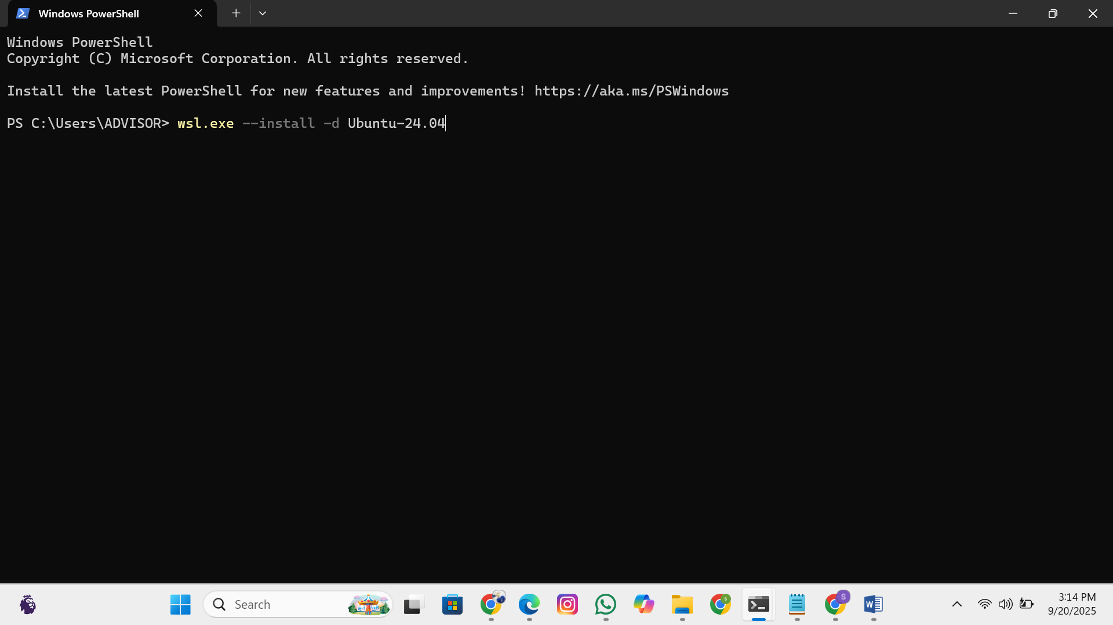

**Task 02: Verifying setup on Windows**

Step 1: Open Ubuntu 24.04 in Windows terminal or Ubuntu shell directly

**Step 2: Create new user and password**

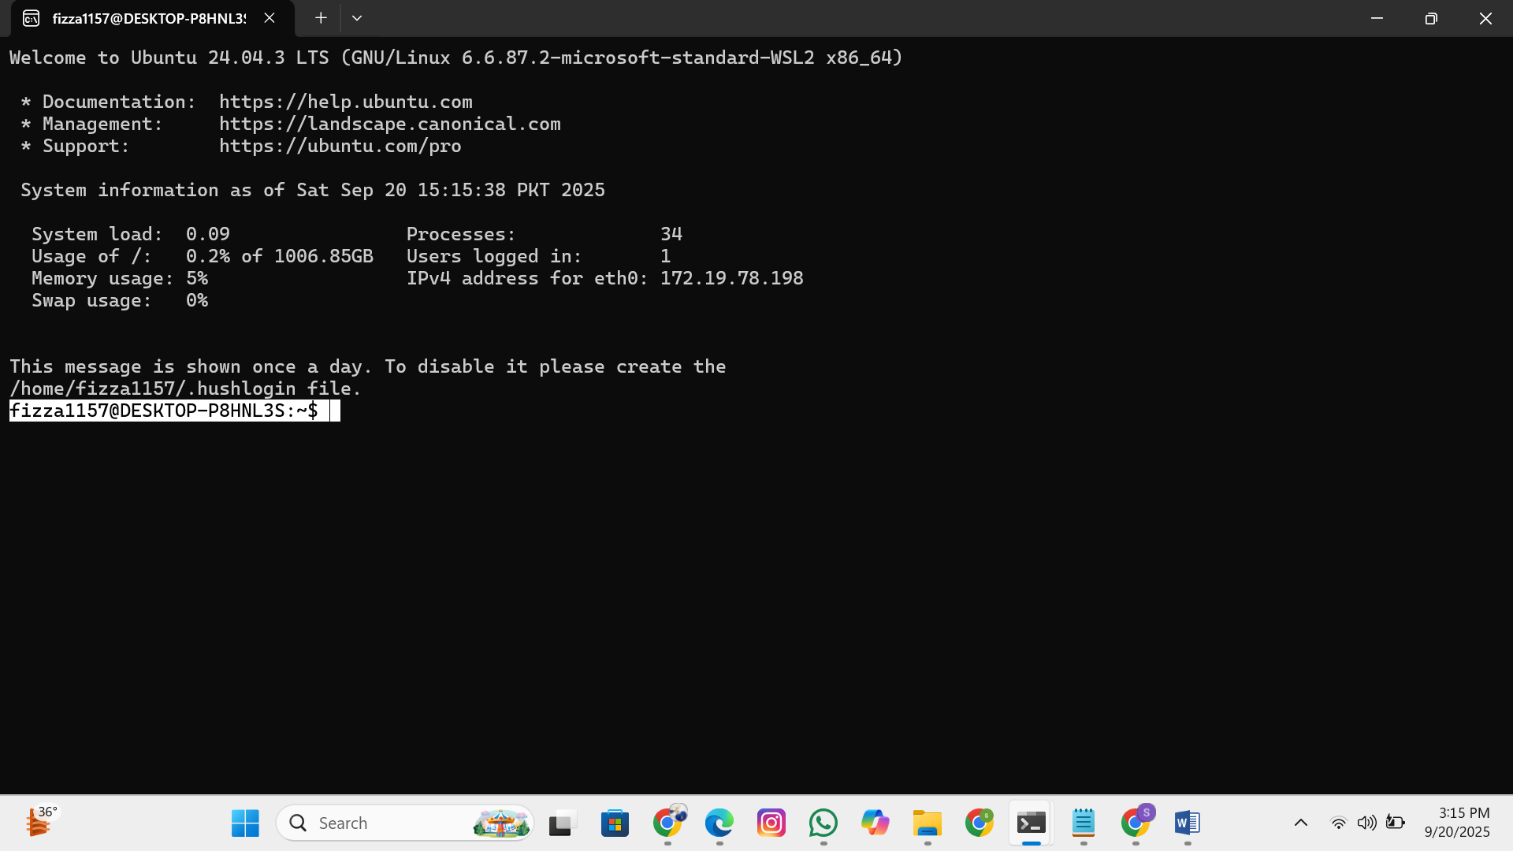

**Step 3: Run the following commands sudo apt update sudoapt upgrade**

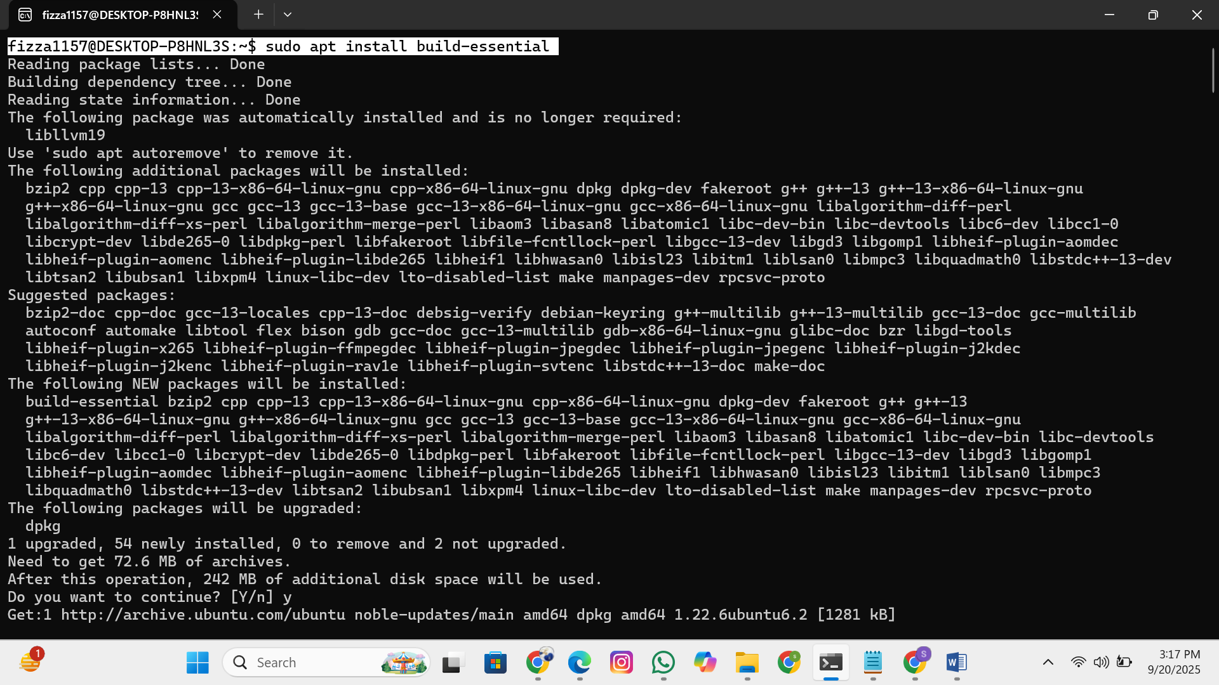

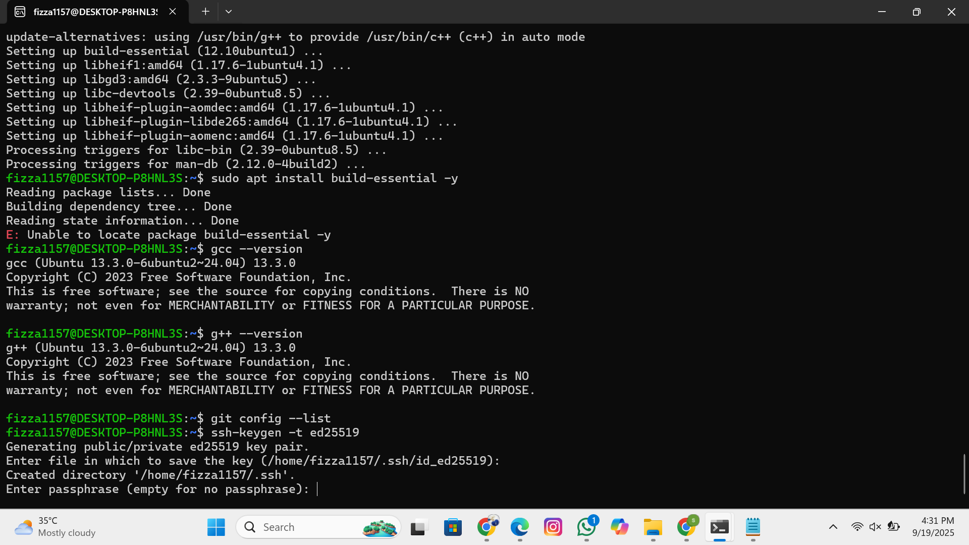

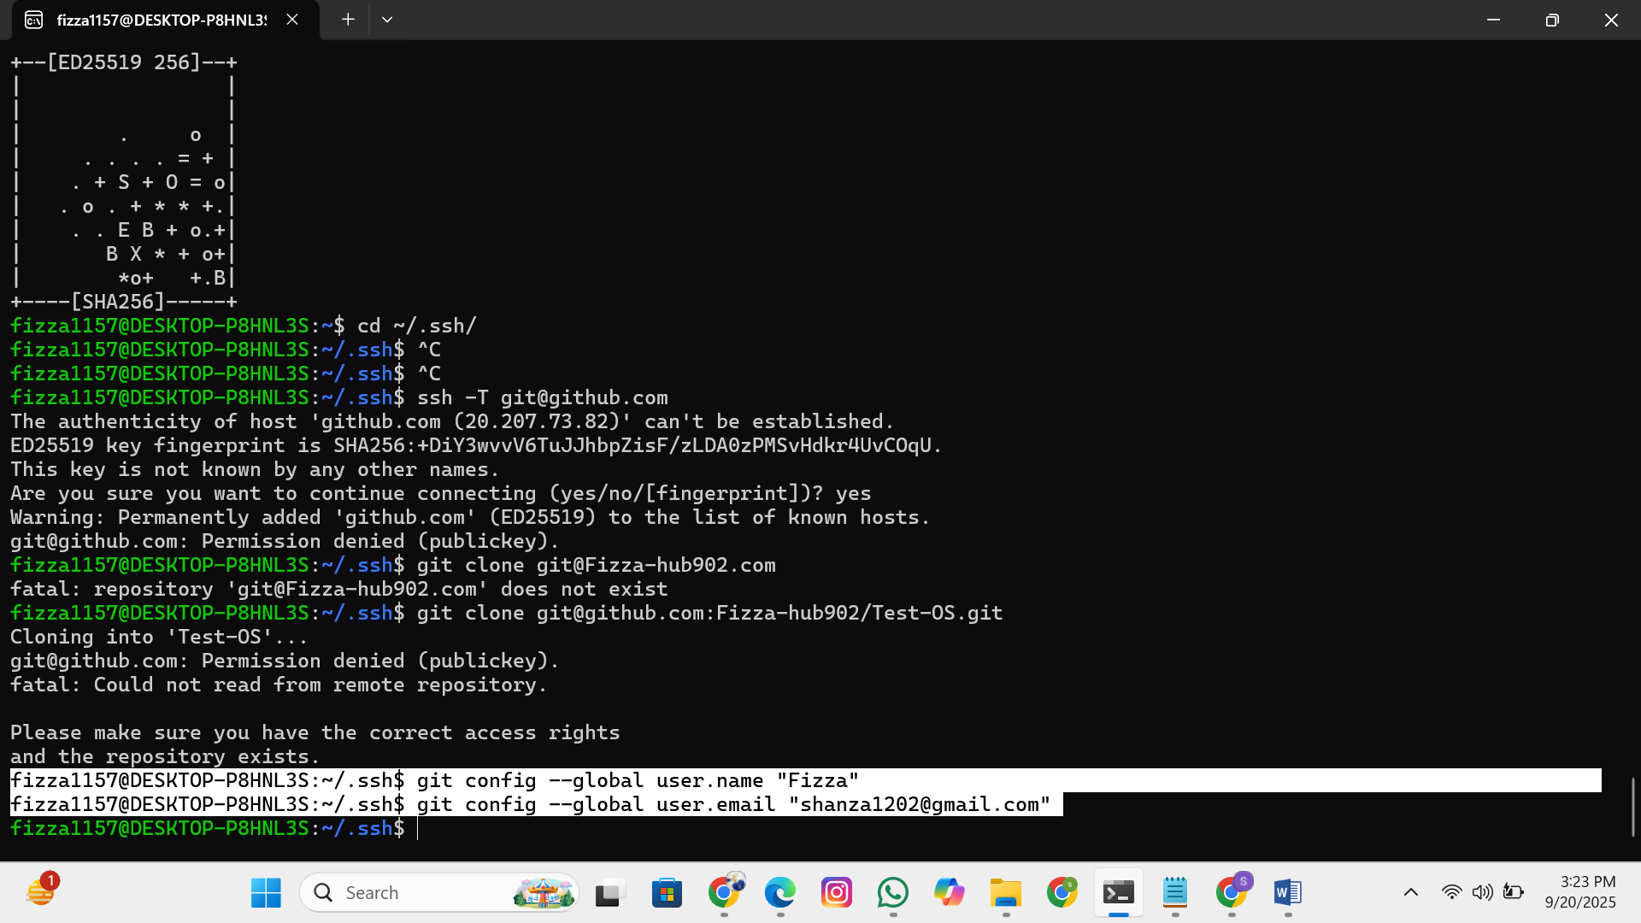

**Generate SSH Key:**

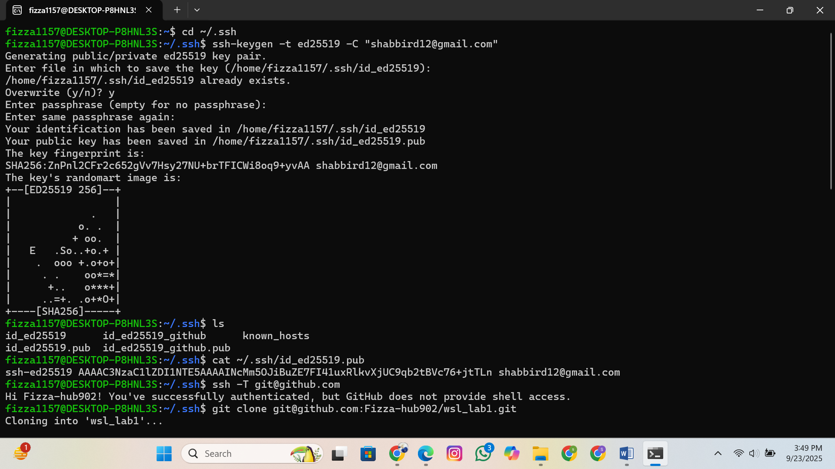

**Navigate to SSH Folder:**

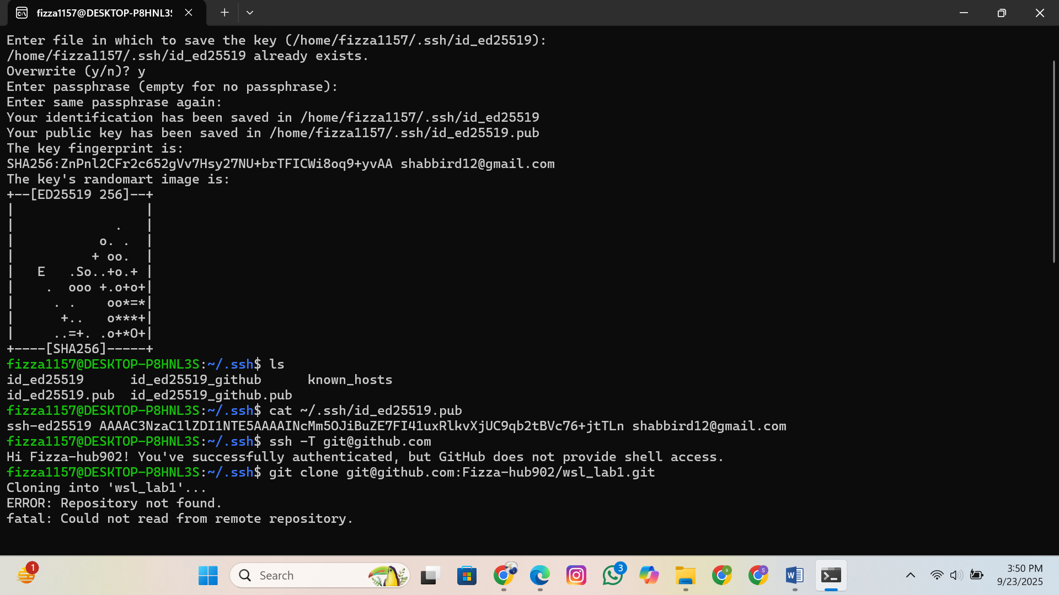

**Copy Public Key and add to Github and then test connection:**

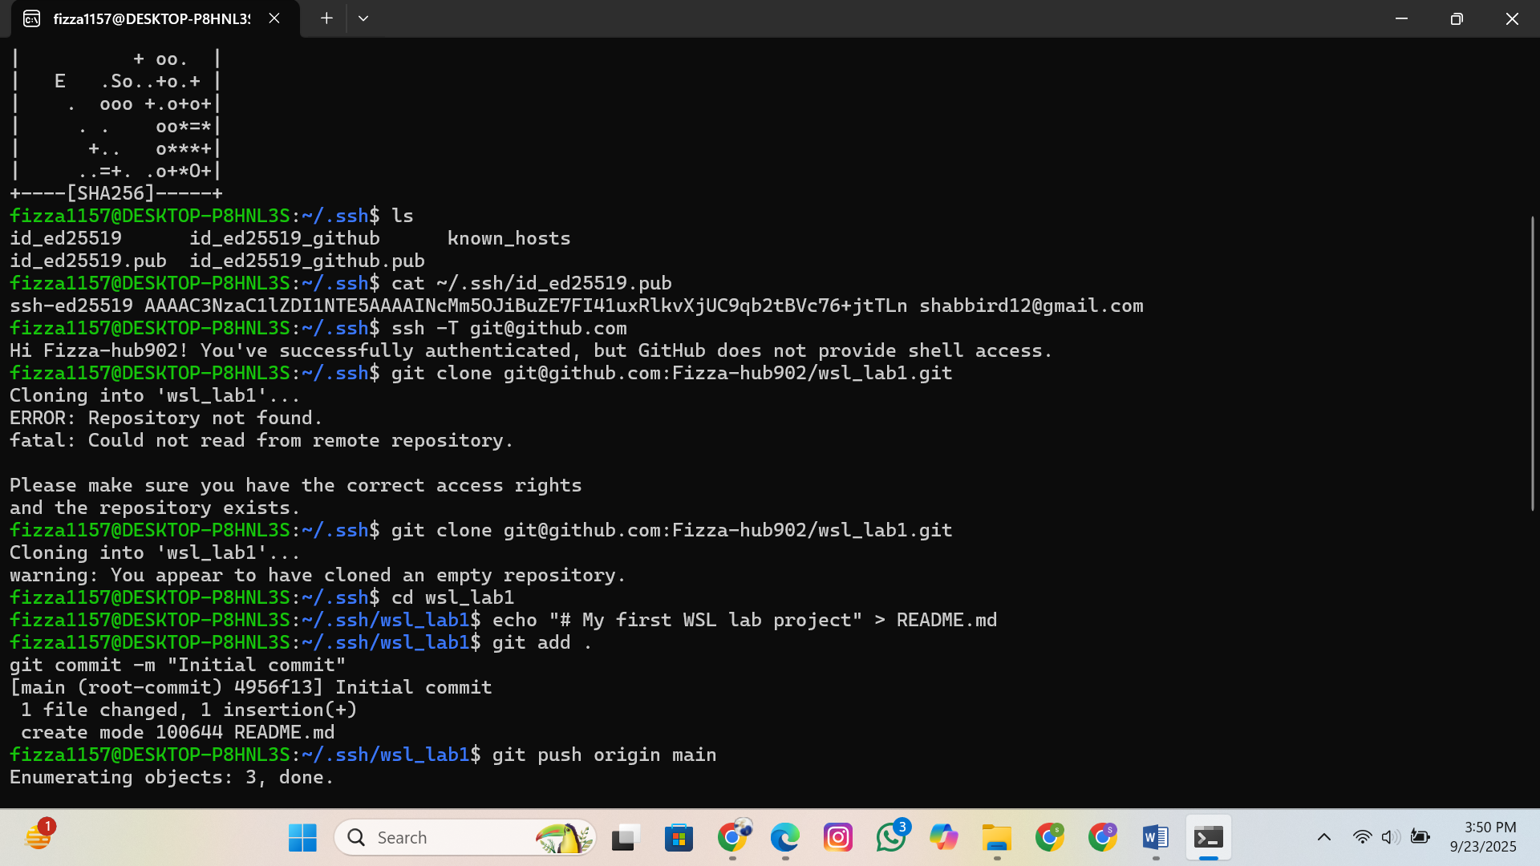

**Clone Repo via SSH**

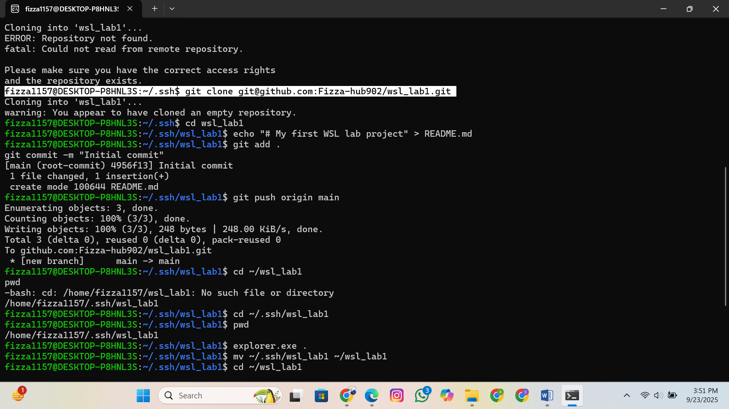

Task 03: Linux filesystem and directory structure

**Step 1: Explore Linux filesystem and basic linux files.**

**Step 2: Explore how Ubuntu (Linux) can access Windows file system under /mnt/c/.**

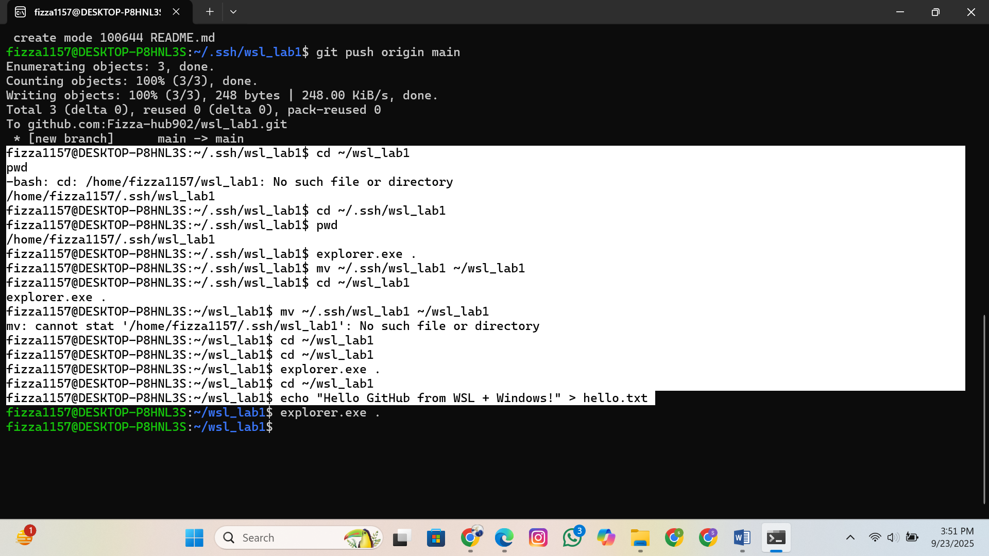

**Step 3: Practice creating files in Windows and accessing them in Ubuntu.**

